Deanery Church of England Primary School
Mental Health and
Wellbeing Newsletter
www.deanery.bham.sch.uk May 2023

This week in Mental Health Awareness Week. The theme of the week this year is ‘anxiety’. Anxiety is a normal emotion to us all, but sometimes it can get out of control and become a mental health and wellbeing issue.

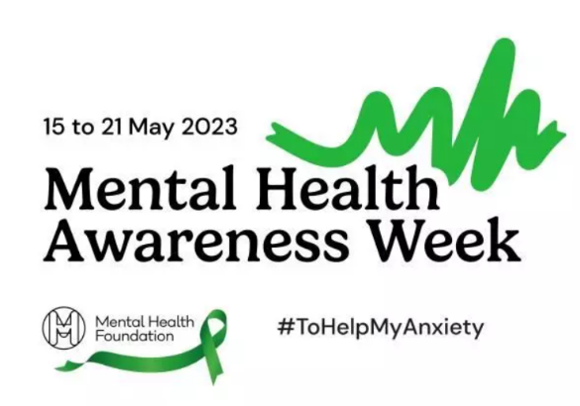
Anxiety is one of the most common mental health problems we can face. We hope that the focus on anxiety in this year’s Mental Health Awareness Week will increase children’s awareness and understanding of anxiety by providing information on the things we can do to help anxiety from becoming a bigger problem.

What is anxiety?

Anxiety is a feeling of worry or fear that is experienced as a combination of physical sensations, thoughts and feelings.

PHYSICAL SYMPTOMS | THOUGHTS & FEELINGS | CHANGES IN BEHAVIOUR
- panic attacks, which can include having a racing heart, breathing very quickly, sweating or shaking  - shallow or quick breathing, or feeling unable to breathe  - feeling sick  - dry mouth  - sweating more than usual  - tense muscles  - wobbly legs  - irritable bowel syndrome (IBS), diarrhoea or needing to wee more than usual  - getting very hot | - preoccupied by scary or negative thoughts, nervous, on edge, panicky or frightened  - overwhelmed  - alert to noises, smells or sights  - worrying about being unable to cope with daily things like school, friendships and being in groups or social situations  - worrying so much that it is difficult to concentrate and/or sleep | - Poor sleep  - Loss of appetite or over-eating  - Decline in academic performance  - Withdrawal from friends and activities  - Loss of enjoyment and pleasure  - Avoidance

All children and young people feel worried sometimes, and this is a normal part of growing up. At certain points, such as on their first day of school or before an exam, young people may become more worried, but will soon be able to calm down and feel better.
Anxiety can become a problem when a young person feels stuck in it, or when it feels like an overwhelming, distressing or unmanageable experience. If this kind of worrying goes on for a long time, it can leave a young person feeling exhausted and isolated, and limit the things they feel able to do.
If your child is struggling with anxiety, there are things you can do to help them – including providing emotional support, working on practical strategies together and finding the right professional help if they need it.

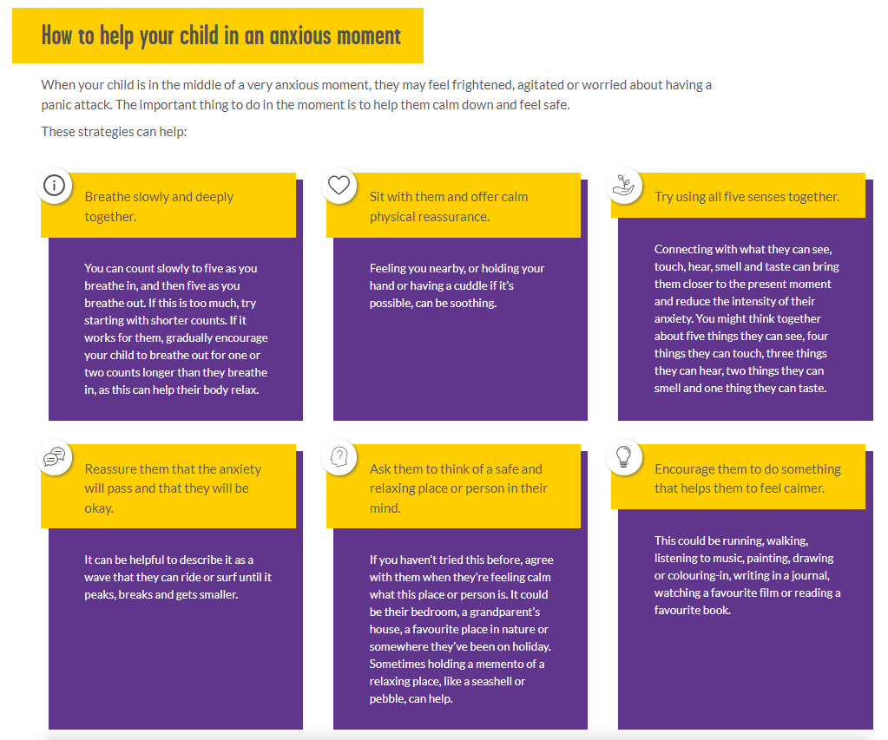

https://www.youngminds.org.uk/

For more information, please see

https://www.youngminds.org.uk/parent/parents-a-z-mental-health-guide/anxiety/
https://www.mentalhealth.org.uk/our-work/public-engagement/mental-health-awareness-week
https://www.nhs.uk/mental-health/children-and-young-adults/advice-for-parents/anxiety-in-children/

