Deanery Church of England Primary School
Mental Health and
Wellbeing Newsletter
www.deanery.bham.sch.uk April 2023

Welcome to our second mental health and wellbeing newsletter.

Mental health challenges can make it difficult for children to achieve in school, form friendships and make positive choices that can impact the rest of their lives.

We are committed to ensuring that emotional health and wellbeing is embedded into our ethos and are proud to share some of the ways in which we support our children’s mental health and wellbeing

Our recent pupil view questionnaire shows
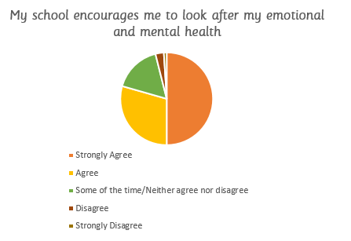
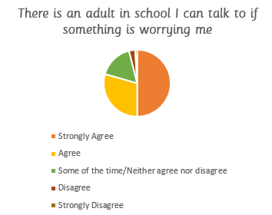

In our mental health and wellbeing survey, we asked if parents know where to find information and support on mental health and emotional wellbeing for their children.

Nearly a quarter of respondents said they would welcome more information.
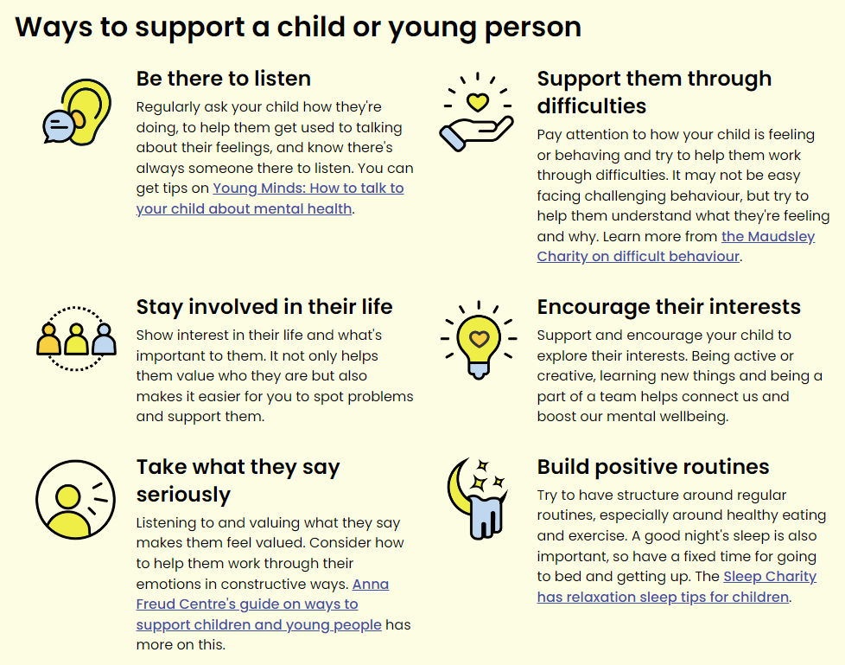
How can we support our children?

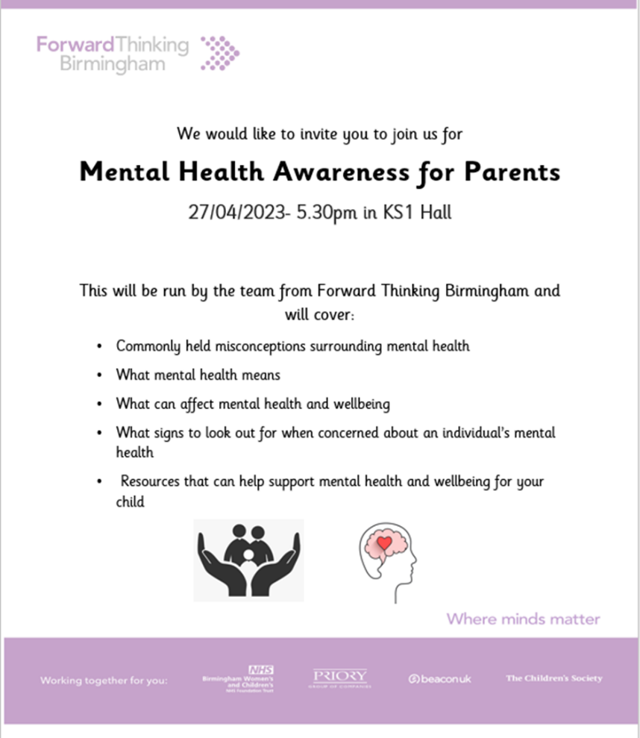

General Practitioners (GPs) are a frontline service for young people struggling with mental ill health. They can play a crucial role in providing advice to young people, and in making referrals to specialist support which can be life changing

Other services offering support include:
https://www.nhs.uk/every-mind-matters/supporting-others/childrens-mental-health/
https://bwc.nhs.uk/parents-and-carers/ https://www.youngminds.org.uk/parent/
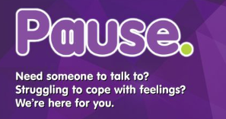

https://forwardthinkingbirmingham.nhs.uk/pause/

https://www.cherisheduk.org/
https://www.nspcc.org.uk/keeping-children-safe/childrens-mental-health/
https://www.barnardos.org.uk/what-we-do/support-for-parents-and-carers/mental-health/supporting-your-child

