Deanery Church of England Primary School
Mental Health and
Wellbeing Newsletter
www.deanery.bham.sch.uk March 2023

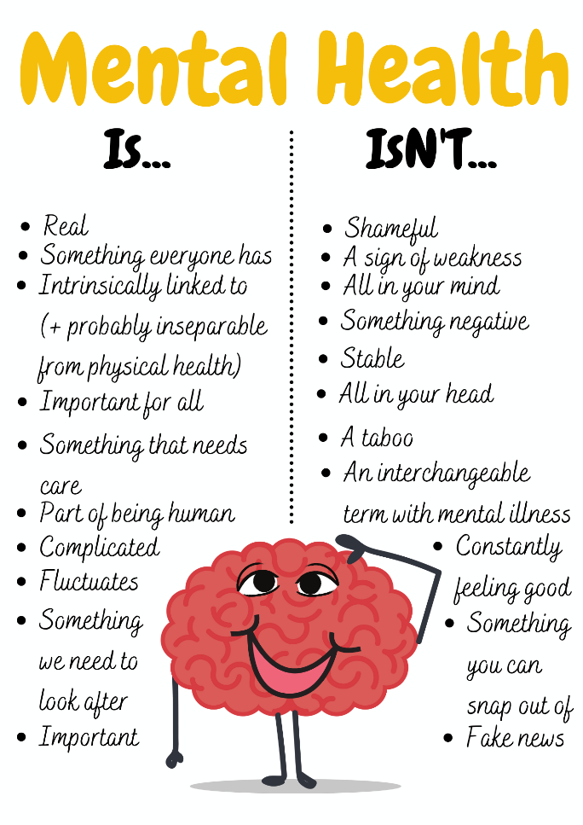
Welcome to our first mental health newsletter.

Wellbeing is high on our list of priorities for our children, parents and staff; we are constantly looking at our current practice and ways that we can improve and enhance the mental health and wellbeing of our whole school community.

Thank you to all of you that completed the mental health and wellbeing survey in January.
Through our new monthly newsletters we will seek to keep you informed of what we are doing in school with regards to mental health and wellbeing and how we can support the wider community.

We will also signpost you to services and websites that may be useful to you.

___________________________________________________________________________

Our recent mental health and wellbeing survey showed the following:

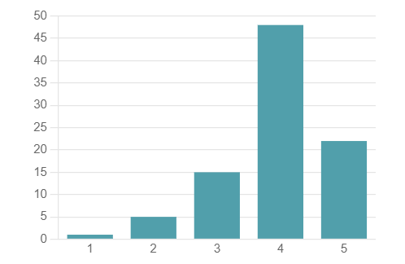
My child's school has a culture and ethos that
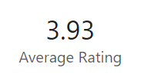
promotes good mental health and emotional wellbeing

1=strongly disagree, 2=disagree, 3= neither agree or disagree
4= agree, 5=strongly agree

How we promote good mental health and wellbeing:
PSHE
All of our children receive a weekly PSHE lesson based on the SCARf scheme. SCARF's whole-school approach promotes positive behaviour, mental health, wellbeing, resilience and achievement.
We cover units such as:
- Me and my relationships
- Valuing difference
- Keeping safe
- Rights and respect
- Being my best
- Growing and changing

We also respond to current issues within classes, school or the wider world within our PSHE sessions and our Friday morning focus on current affairs.

Enrichment
At Deanery, we feel that it is important to develop the whole child and to allow children to shine in all different areas. Our Enrichment programme provides the children with a choice of activities such as photography, outdoor activities, construction, French, cooking and many more.
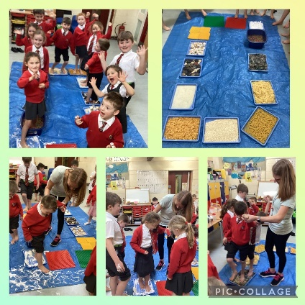
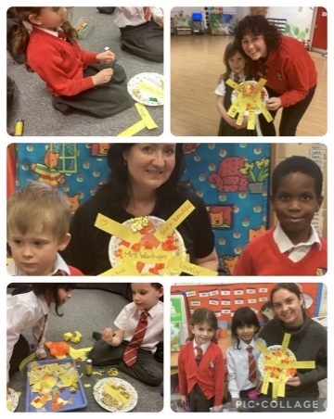

__________________________________________________________________________________
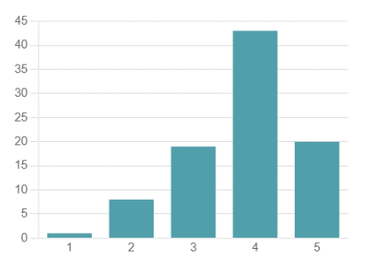
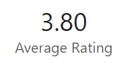
I feel confident that the school is able to support the
mental health and emotional wellbeing needs of my child.

All of our staff receive continual training in mental health and wellbeing, however we do have a team of staff who work more closely with mental health and wellbeing in school.

Deanery Team
If you have any concerns or questions regarding mental health and wellbeing, you are welcome to speak to:
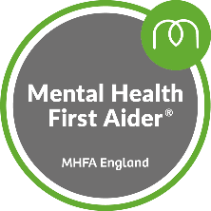
Miss A Morris – Deputy Head & Mental Health Lead & Jolly Jungle mentor
    - Trained Mental Health First Aider
    - L3 award in mentoring
    - CACHE L2 award in counselling skills
    - CACHE L2 award in understanding mental haelth first aid and mental health advocacy in the workplace
- CACHE Level 2 Certificate in Understanding Adverse Childhood Experiences
- Department for Education approved mental health lead training
Mrs J Griffiths – Inclusion Manager & Jolly Jungle Mentor
    - L3 award in mentoring

Mrs J Johanson – Jolly Jungle mentor
- Barriers to learning
- Drawing through emotion.
- Bereavement counselling

Mrs S Solomon – Trained Adult Mental Health First Aider

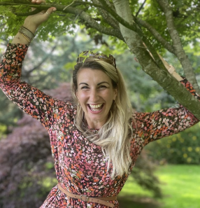

Mrs R Armstrong – Governor for mental health and well-being

We fully accept that we will not always have the answers and therefore seek the support and guidance of services such as Our Place, Forward Thinking Birmingham, Cherished, STICK team to name but a few in order to best support or children.

Jolly Jungle
I know about Deanery’s Jolly Jungle and understand the work it does with children
Why do we have a Jolly Jungle?
We recognise that many children, at different times in their school lives, experience difficulties in coping with some of the pressures and situations in which they find themselves. This may be the result of challenges facing them with their schoolwork, relationships with their peers, or difficulties arising at home (family illness, bereavement, job loss, relationship issues etc.). Often these difficulties may be short lived but can have a long-term effect upon children’s self-esteem or attitudes to school. All of our children receive a weekly PSHE lesson based on the SCARf scheme but this is not always enough.
There is sufficient evidence, from research into children’s development, to indicate that at such times, young people benefit from the support of a trained individual, who has a key responsibility to ensure that the children are listened to, helped to work through difficulties and given the confidence to find solutions to their problems.
What is Jolly Jungle?
Jolly Jungle is a ‘safe’ environment where children have the opportunity to:
- express their feelings, fears and worries
- identify and recognise their own strengths and talents
- work out solutions for themselves
Who looks after Jolly Jungle?
Mrs Johansen heads up the Jolly Jungle team and along with Mrs Griffiths and Miss Morris will see children for a 6 week mentoring block. The mentoring programme is goal driven and we work with each child to set their own goals and work on strategies to achieve them.
We will allocate a member of staff to each child depending on expertise and background.
If you would like to know more about Jolly Jungle, or wish to access a referral form, please see https://www.deanery.bham.sch.uk/inclusion/jolly-jungle
If you wish to discuss anything further, please contact the team via jollyjungle@deanery.bham.sch.uk and one of the team will get back to you.

