Curriculum Support for P.E

Aspire Sports

The school invest in Aspire Sports specialists who support Years 2 and 3 in P.E lessons every week. Aspire also run our Bikeability program for Year 5 and Year 6, as well as our Balanceability program for Reception.

Relax Kids
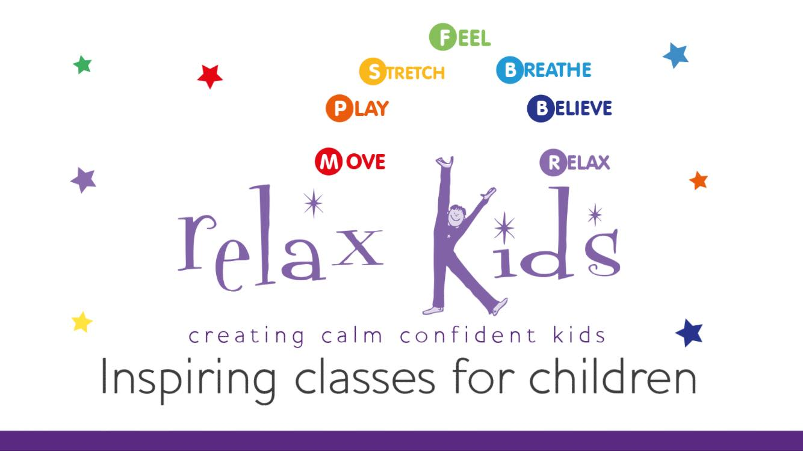

This year, we have had the opportunity to have Relax Kids in for children in KS2. Relax Kids is serious fun with a serious learning objective. Young people learn to feel calm & focussed in the face of potentially stressful situations, build a better understanding of their emotions & are armed with the skills to strengthen their own mental wellbeing, whilst navigating the challenges & pit falls that life inevitably brings.
FA Lidl Sports Coaching

In the autumn term, an FA Lidl Sport Coach supported teachers in years 4 and 5 to plan consecutive lessons. The children develop a range of skills through invasion games, with a focus on football, such as passing, marking, and keeping possession. Children developed their role as part of a team as well as ensuring they are playing in a supportive and conscientious manner. The teachers have now achieved the PTA award.

Swimming Lessons
Deanery provide swimming lessons with Castle Vale Swimming Pool. We offer an intensive multi week programme for our Year 3 children.
Warwickshire Cricket

In the spring term, children in year 5 receive a 6 week block of coaching from Warwickshire Cricket and then take part in a Cricket Festival to demonstrate the skills they have learnt and developed.

