Deanery Team
If you have any concerns or questions regarding mental health and wellbeing, you are welcome to speak to:
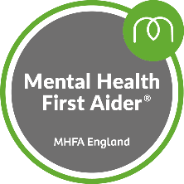
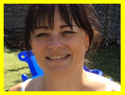
Miss A Morris – Deputy Head & Mental Health Lead & Jolly Jungle mentor
    - Trained Mental Health First Aider
    - L3 award in mentoring
    - CACHE L2 award in counselling skills
    - CACHE L2 award in understanding mental haelth first aid and mental health advocacy in the workplace
- CACHE Level 2 Certificate in Understanding Adverse Childhood Experiences
- Department for Education approved mental health lead training
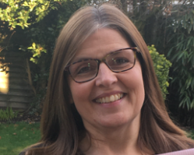
Mrs J Griffiths – Inclusion Manager & Jolly Jungle Mentor
    - L3 award in mentoring

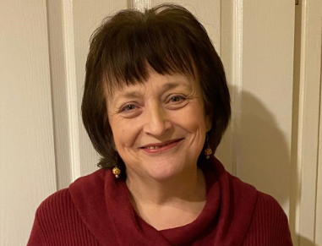
Mrs J Johanson – Jolly Jungle mentor
- Barriers to learning
- Drawing through emotion.
- Bereavement counselling

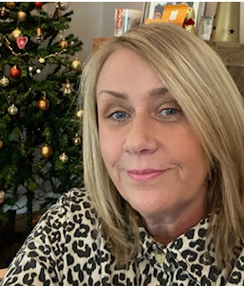
Mrs S Solomon – Trained Adult Mental Health First Aider

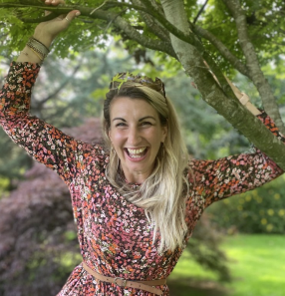

Mrs R Armstrong – Governor for mental health and well-being

We fully accept that we will not always have the answers and therefore seek the support and guidance of services such as Our Place, Forward Thinking Birmingham, Cherished, STICK team to name but a few in order to best support or children.

