Deanery CE Primary School
Collective Worship

Intent
At Deanery collective worship is a highly valued part of the school day as it is the time when we gather together to affirm what is important to us, to our school and to our world. We take care to plan our collective worship so that it is inclusive, invitational, and inspiring. In our times of collective worship together, the school affirms the claims of Christianity which underpin the values of the school. It provides an opportunity for pupils to encounter God, whilst seeking to be relevant to, and inclusive of, all. It reflects our Anglican tradition as well as exploring with pupils and staff a variety of ways in which Christians worship God.
In acts of Collective Worship in our school it is recognised that in our school community, some members will come from families with a commitment to the Christian faith, others from families with a commitment to another faith and yet others will have no particular commitment to any tradition. Therefore the content and language of collective worship allows for different levels of response. It invites rather than coerces.
Collective worship in our school influences the way that we live together as a community and before God. Members of the community are challenged to think, act and live differently as a result of these times together.

Implementation
Daily assemblies follow a pattern for worship reflecting Anglican tradition of gathering, engaging, responding and sending out. Visitors including clergy are invited to lead assemblies and teaching staff take turns to lead them too. Weekly class prayer allows pupils to respond to themes from assemblies in their own classes. Celebration assemblies include an opportunity to celebrate pupils’ attitudes and achievements.
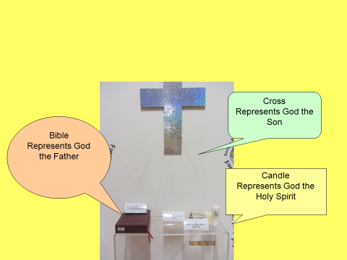
- Gathering – Greeting, liturgy, worship song
- Engaging- Teaching, story
- Responding- e.g. song, prayer, reflection, question –’what have we learnt about Jesus?’
- Sending – Question e.g. ‘How can you show you’re generous? Blessing

A two year cycle of themes has been developed and discussed with local clergy. Year one of the cycle follows the story of the Bible whilst year two of the cycle is linked to our school values. They are intended to be detailed enough to provide both continuity and development of themes and are sufficiently broad to allow a variety of people to lead the assembly in their own distinctive way. On occasions it is recognised that those leading worship may feel that they need to respond to local or national events. We are actively encouraging pupils to make a contribution to planning and helping to lead acts of collective worship with the worship council leading one assembly each half term using the seeing anew approach. Other pupil councils also lead acts of worship.

Worship areas are available for all children in their own classroom or shared area. These are individual to each class and can be accessed by children throughout the day. An outside worship area is available between KS1 and KS2 playground.

An annual cycle of services based on the Christian calendar are celebrated in conjunction with the local Church. Twice a year these services include communion for each key stage.

